Setting Up a Web and DNS Server

Jasmine Roberts

Bowie State University

CTEC435-102-Fall2024 UNIX System Administration

Anthony Adedoyin

December 4, 2024

**Abstract 3**

**Research Approach 4**

History of Web and DNS Server 4

Tasks and Figures of Architecture 4

**Results 12**

What Is the Current Status? 12

Web Servers 12

DNS Servers 12

Current Issues 13

How Are We Using It? 13

Benefits to Society 13

**Future Work 16**

**Summary and Conclusions 16**

**References 18**

# 

# 

# Abstract

This report is about the configuration of a Web and DNS Server, which involves registering a domain name, and having website access. A Web Server is a computer system/software that stores the website's content to users over the internet. A DNS Server translates the domain name(s) into IP addresses. In order to set up both servers, you would need to first install the web server itself within a Linux machine, in this case we used Ubuntu (our host machine) and CentOS. Secondly, we began to configure the DNS Server with the use of many commands, multiple zone files, and creating a map for the domains. Thirdly, we linked the DNS Server with the Web Server, by pointing it to the IP address where the web server website (domain) is hosted on. Lastly, a test was performed to make sure the Web Server and DNS server was properly configured. Our domain name is project435web.online.

*Keywords:* *report, domain, web, dns*

# Research Approach

## History of Web and DNS Server

Initially, a web server was invented by Tim Berner-Lee (a computer scientist), invented the “World Wide Web” in 1989, and created the first Web Server called the “CERN httpd”. A Web Server was invented to initiate the use of automated sharing of information between users. The Web Server can process and manage HTTP/HTTPS requests and responses from the client. Furthermore, the server can be used to store and protect the data from unauthorized users (*CERN Accelerating Science*, n.d.). The Domain Name System (DNS) was invented by Paul Mockapetris ( a computer scientist) in 1983. While creating the DNS, he had a vision for the easier use of networking where people wouldn't need to remember the IP address of each computer. Many years after its invention, the DNS became one of the Internet Standards in 1986 (Petrova, 2023). Additionally, we were able to use “Setting Up a Web and DNS Server”, by picking it randomly among three other topics such as Securing and Hardening a Linux System, Running a Virtual Mail Server, and Automating Linux Administrative Tasks.

## 

## Tasks and Figures of Architecture

In order to complete the tasks of Setting up a Web and DNs Server, you will first need a Linux host machine and then you will need four virtual machines inside of Virtual Box. We were instructed to use the following as virtual machines. (These four Virtual Machines were installed inside of Virtual Box):

* CentOS Server
* Ubuntu Server 4-8
* Ubuntu 22.04 (host machine of our choice)
* Linux Mint 2.1.3

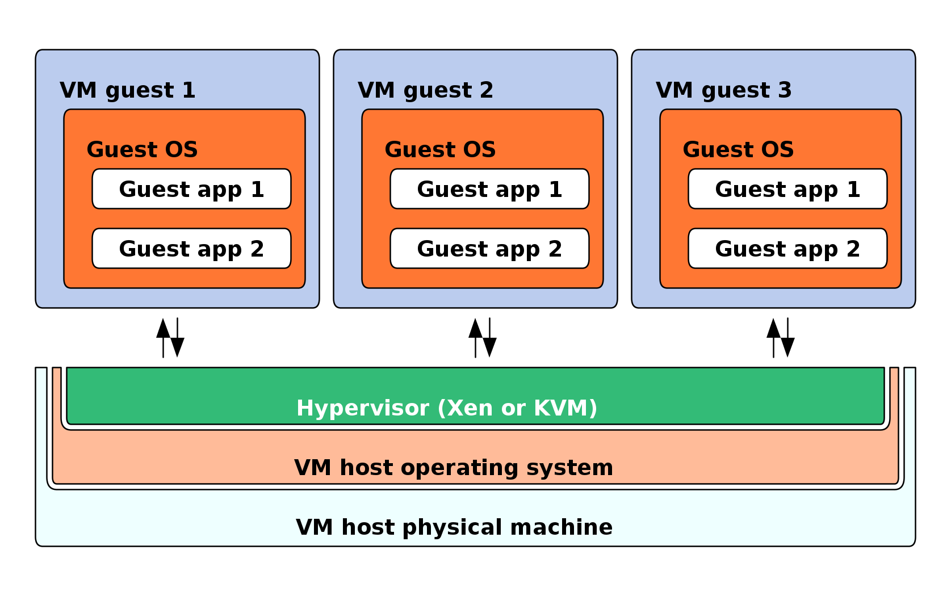

*Figure 1 Host Machine and Additional Virtual Machines(Virtualization, 2024).*

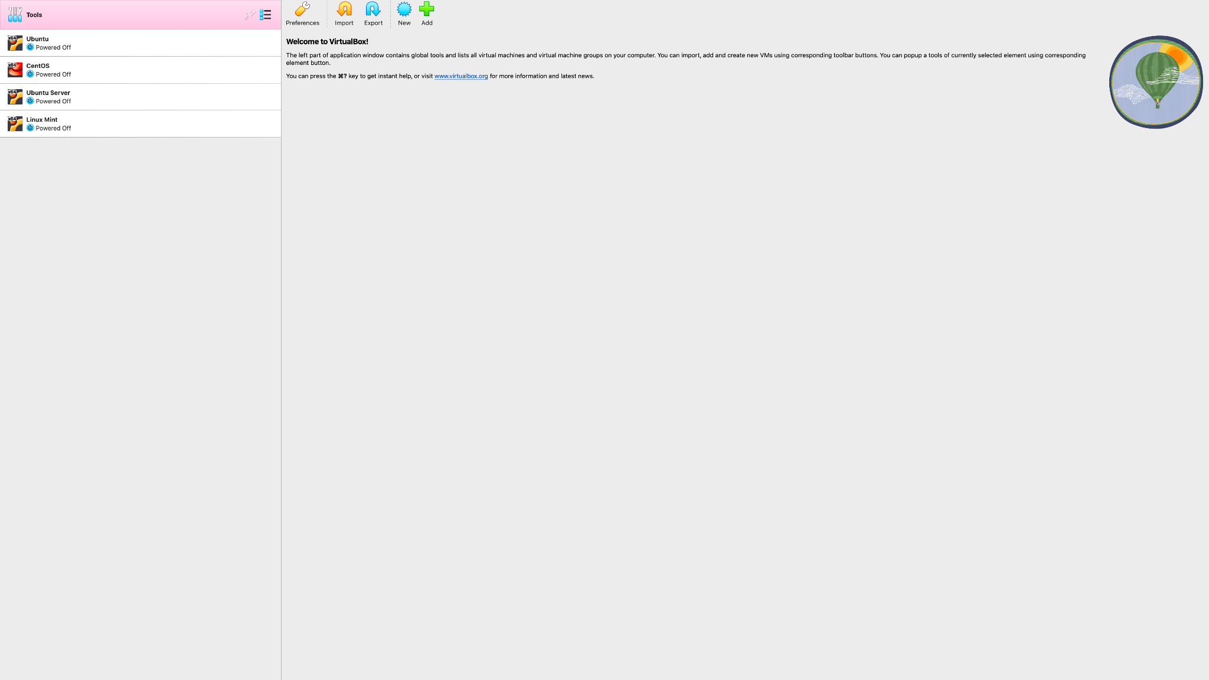

*Figure 2 Virtualbox.*

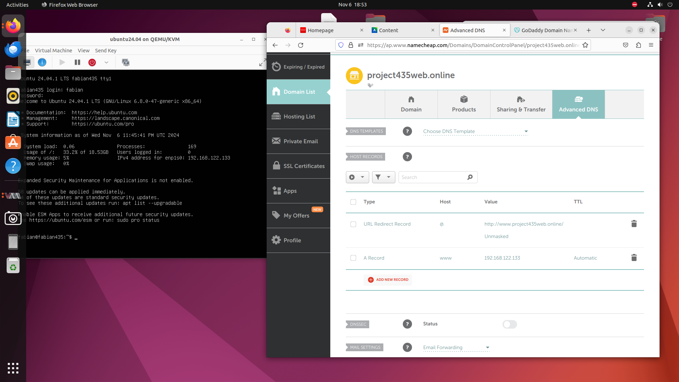

*Figure 3 Domain Name Registration.*

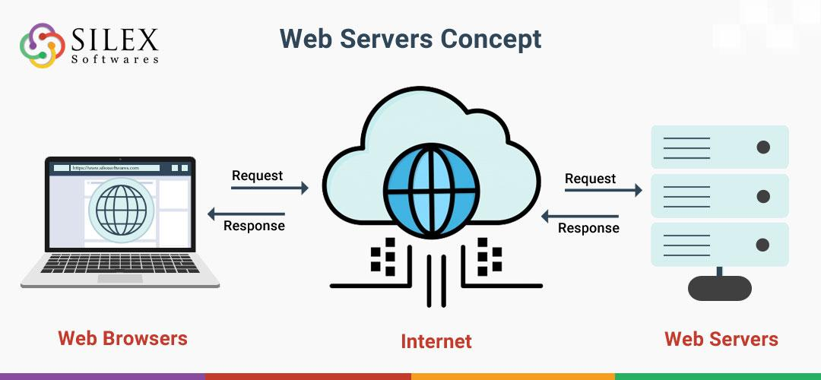

*Figure 4 Topology of the process of Web Servers (Sinah, 2024).*

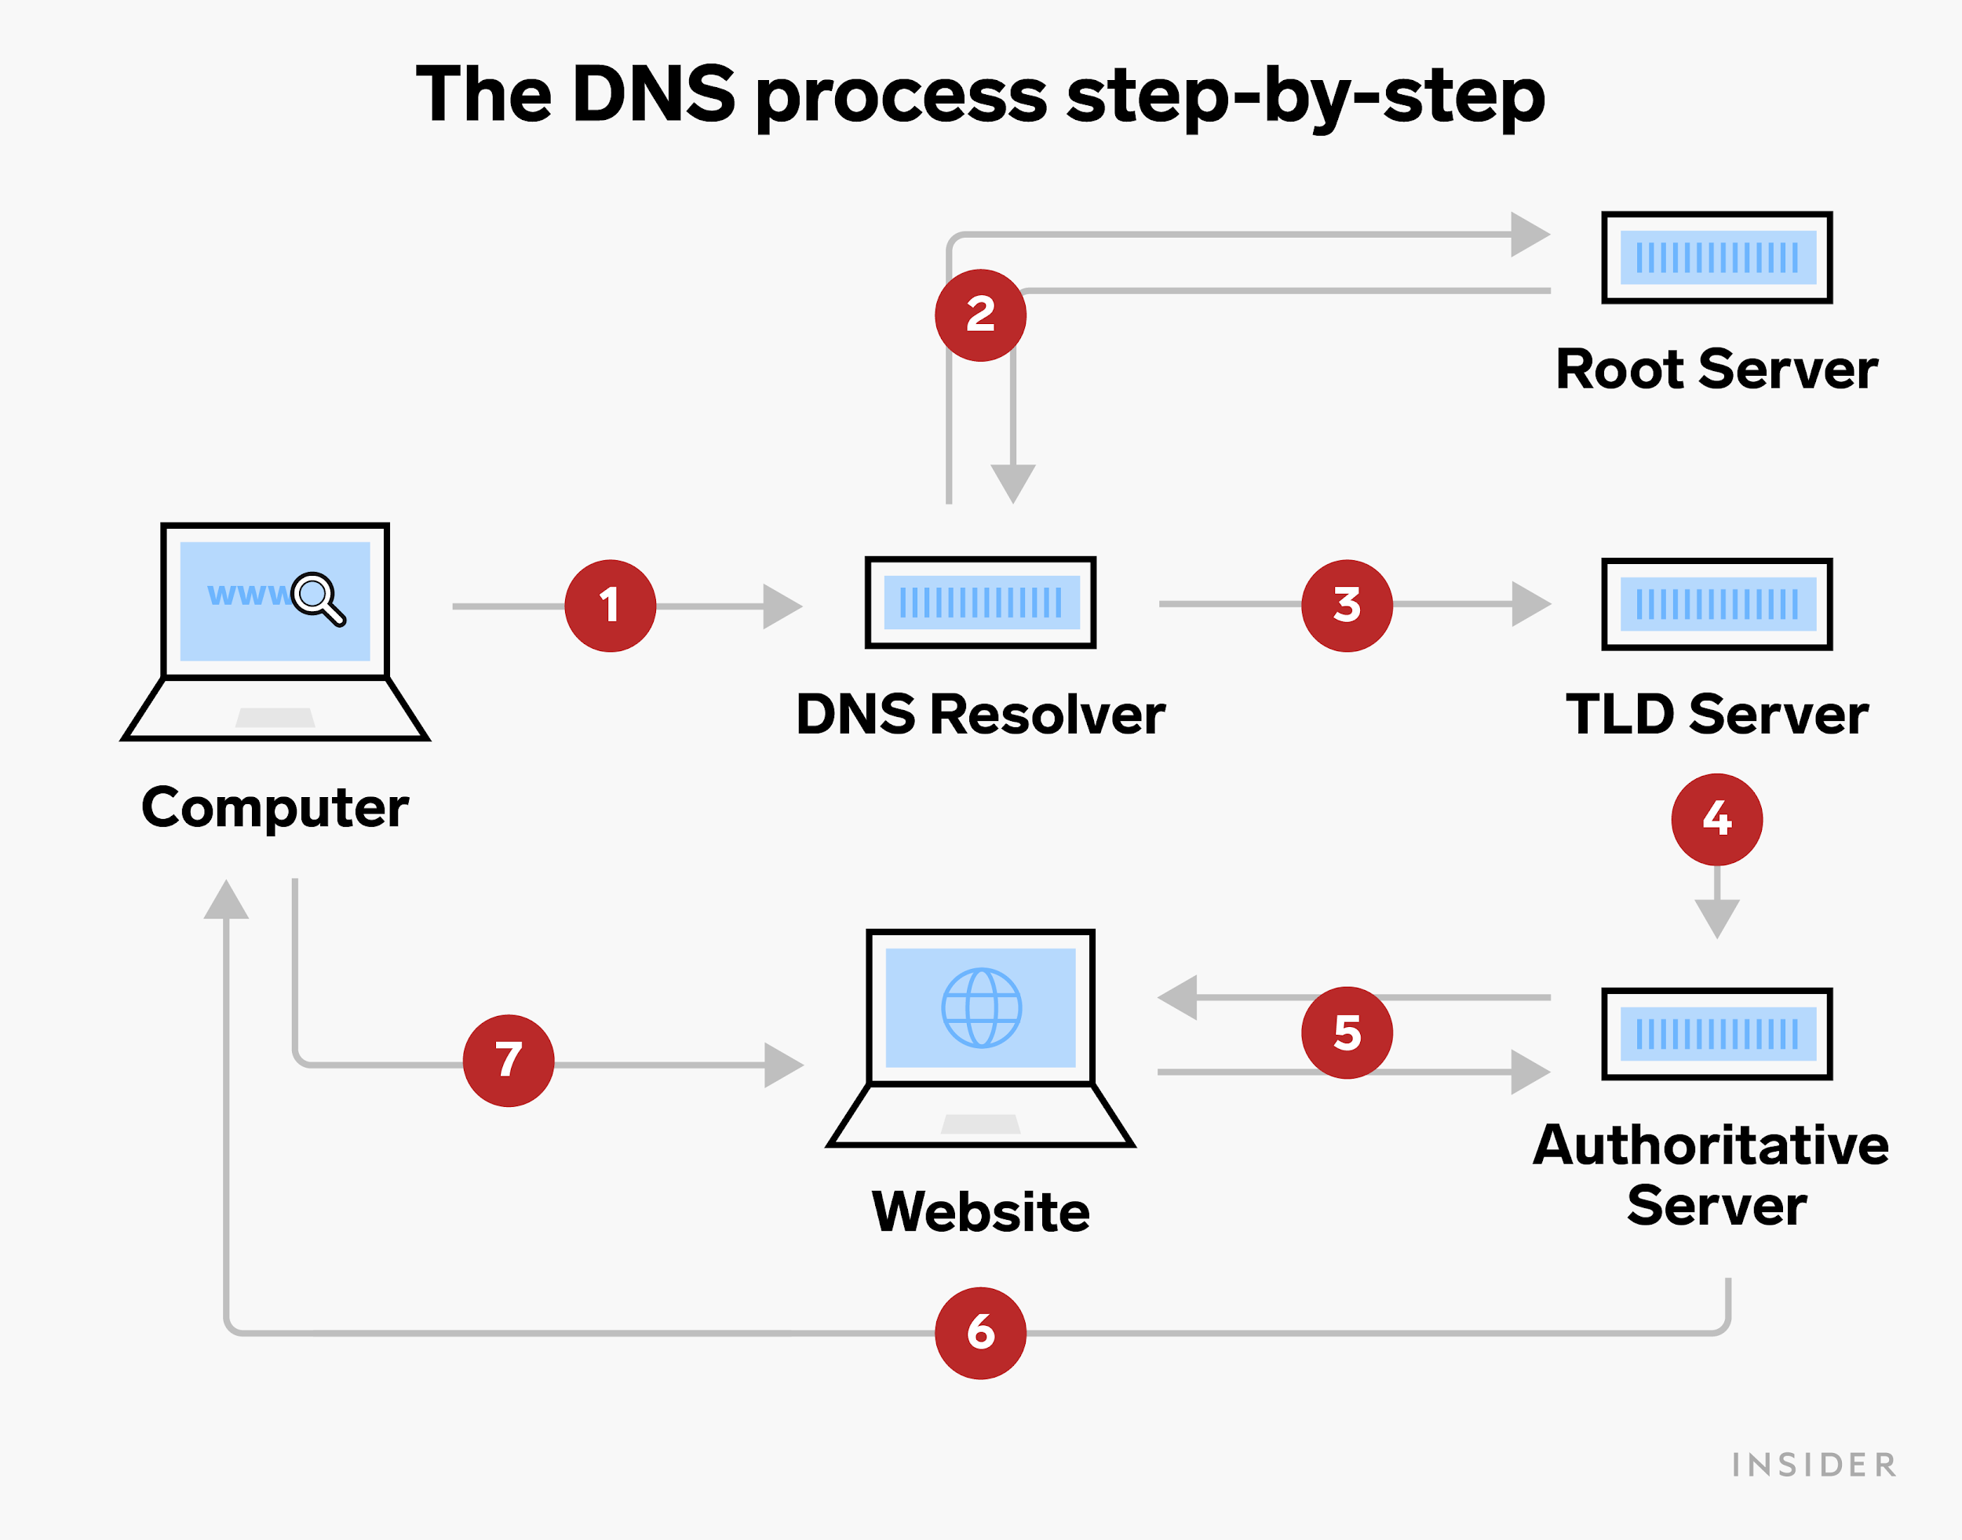

*Figure 5 Topology of the DNS Process.*



*Figure 6*

*Tasks:*

* *Acquiring a Domain name with a DNS and web server*

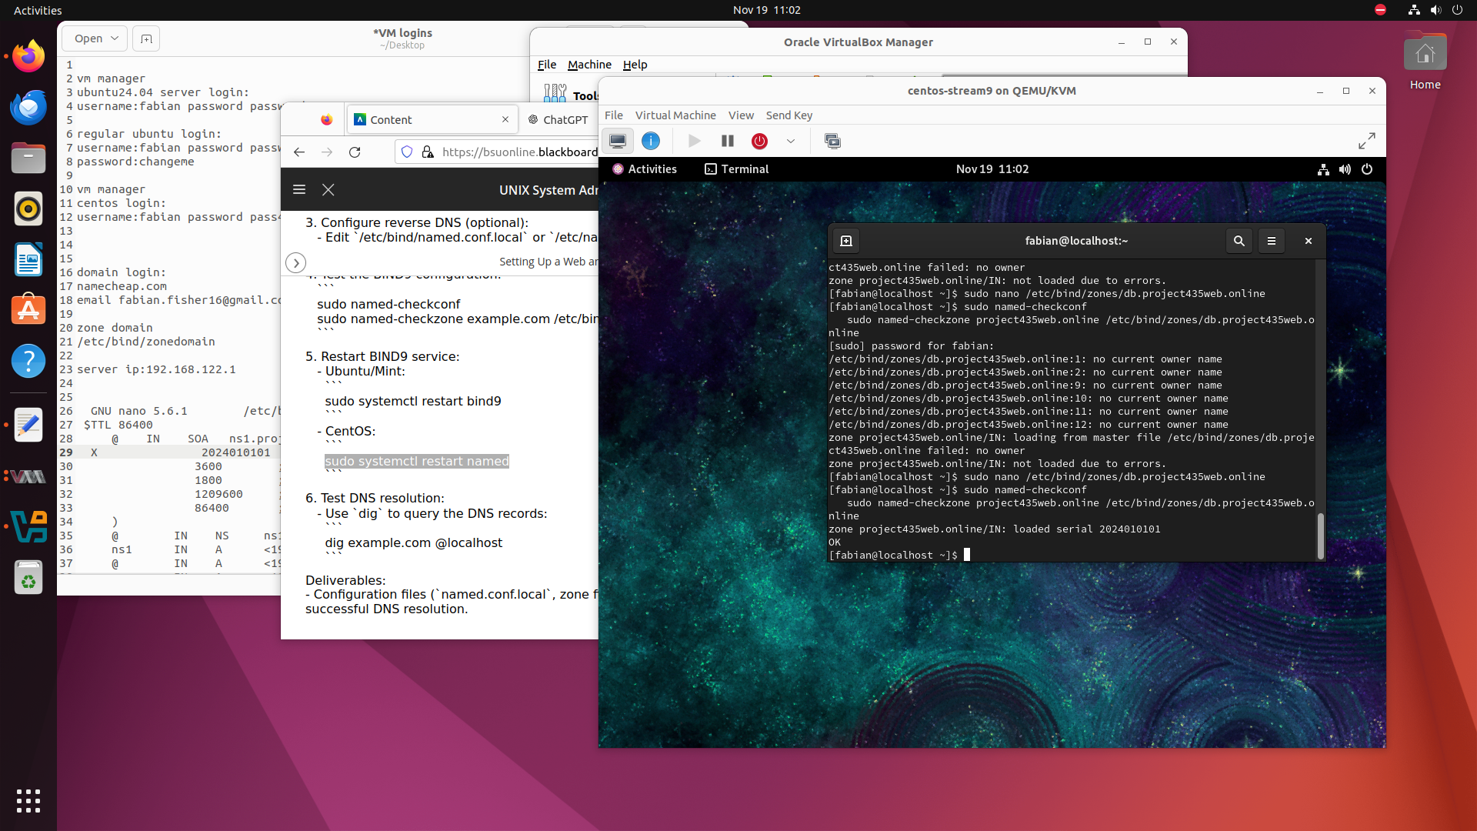

*Figure 7*

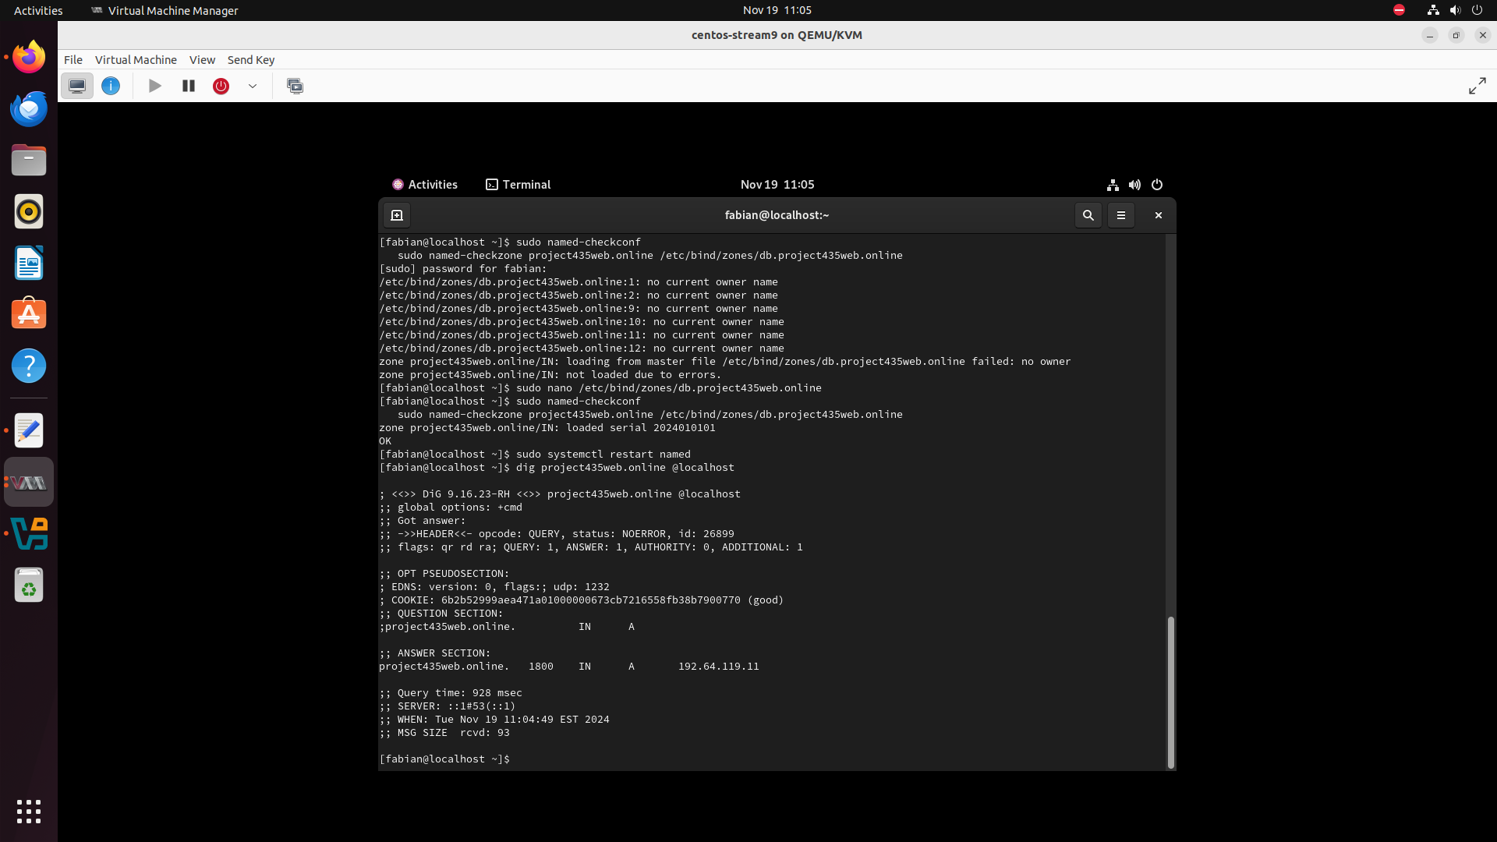

*Figure 8.*

*Tasks:*

* *Installing and configuring BIND9 (DNS Server)*
* *Setting up the Authoritative BIND9 DNS Server*

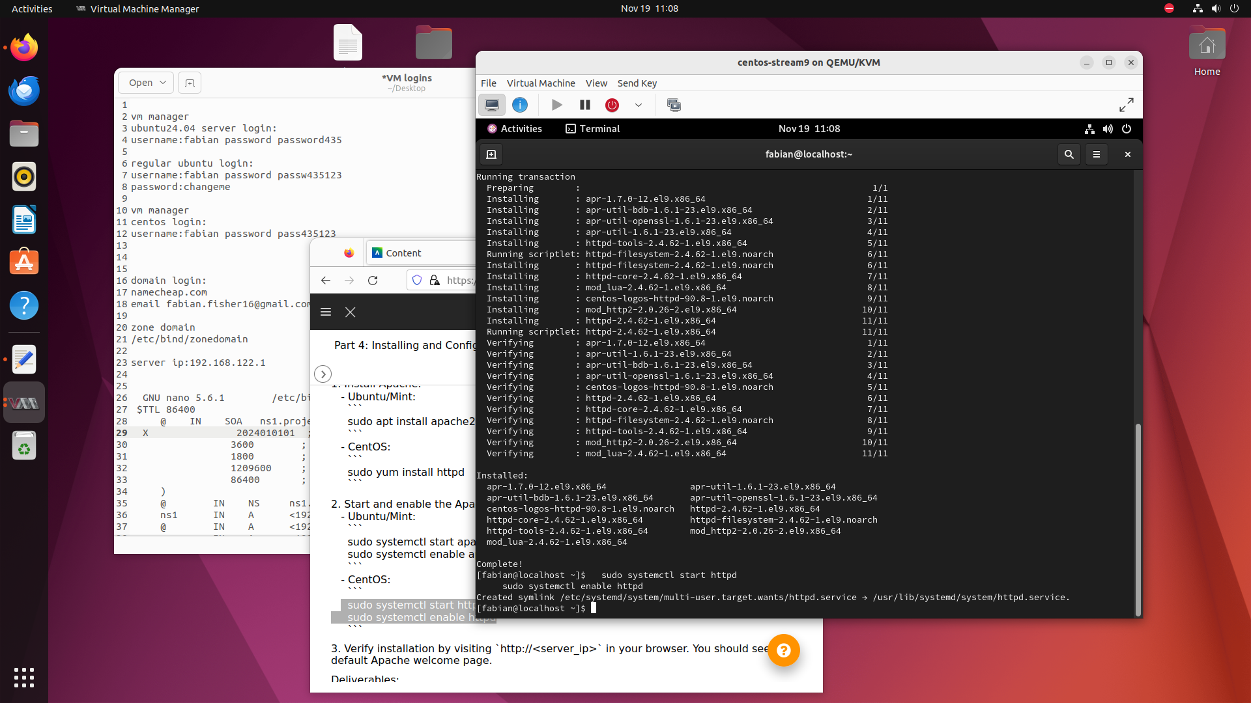

*Figure 9.*

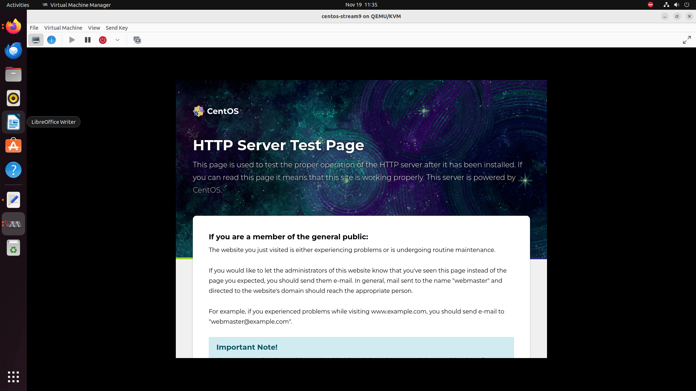

*Figure 10*

*Tasks:*

* *Installing and Configuring Apache Web Server*

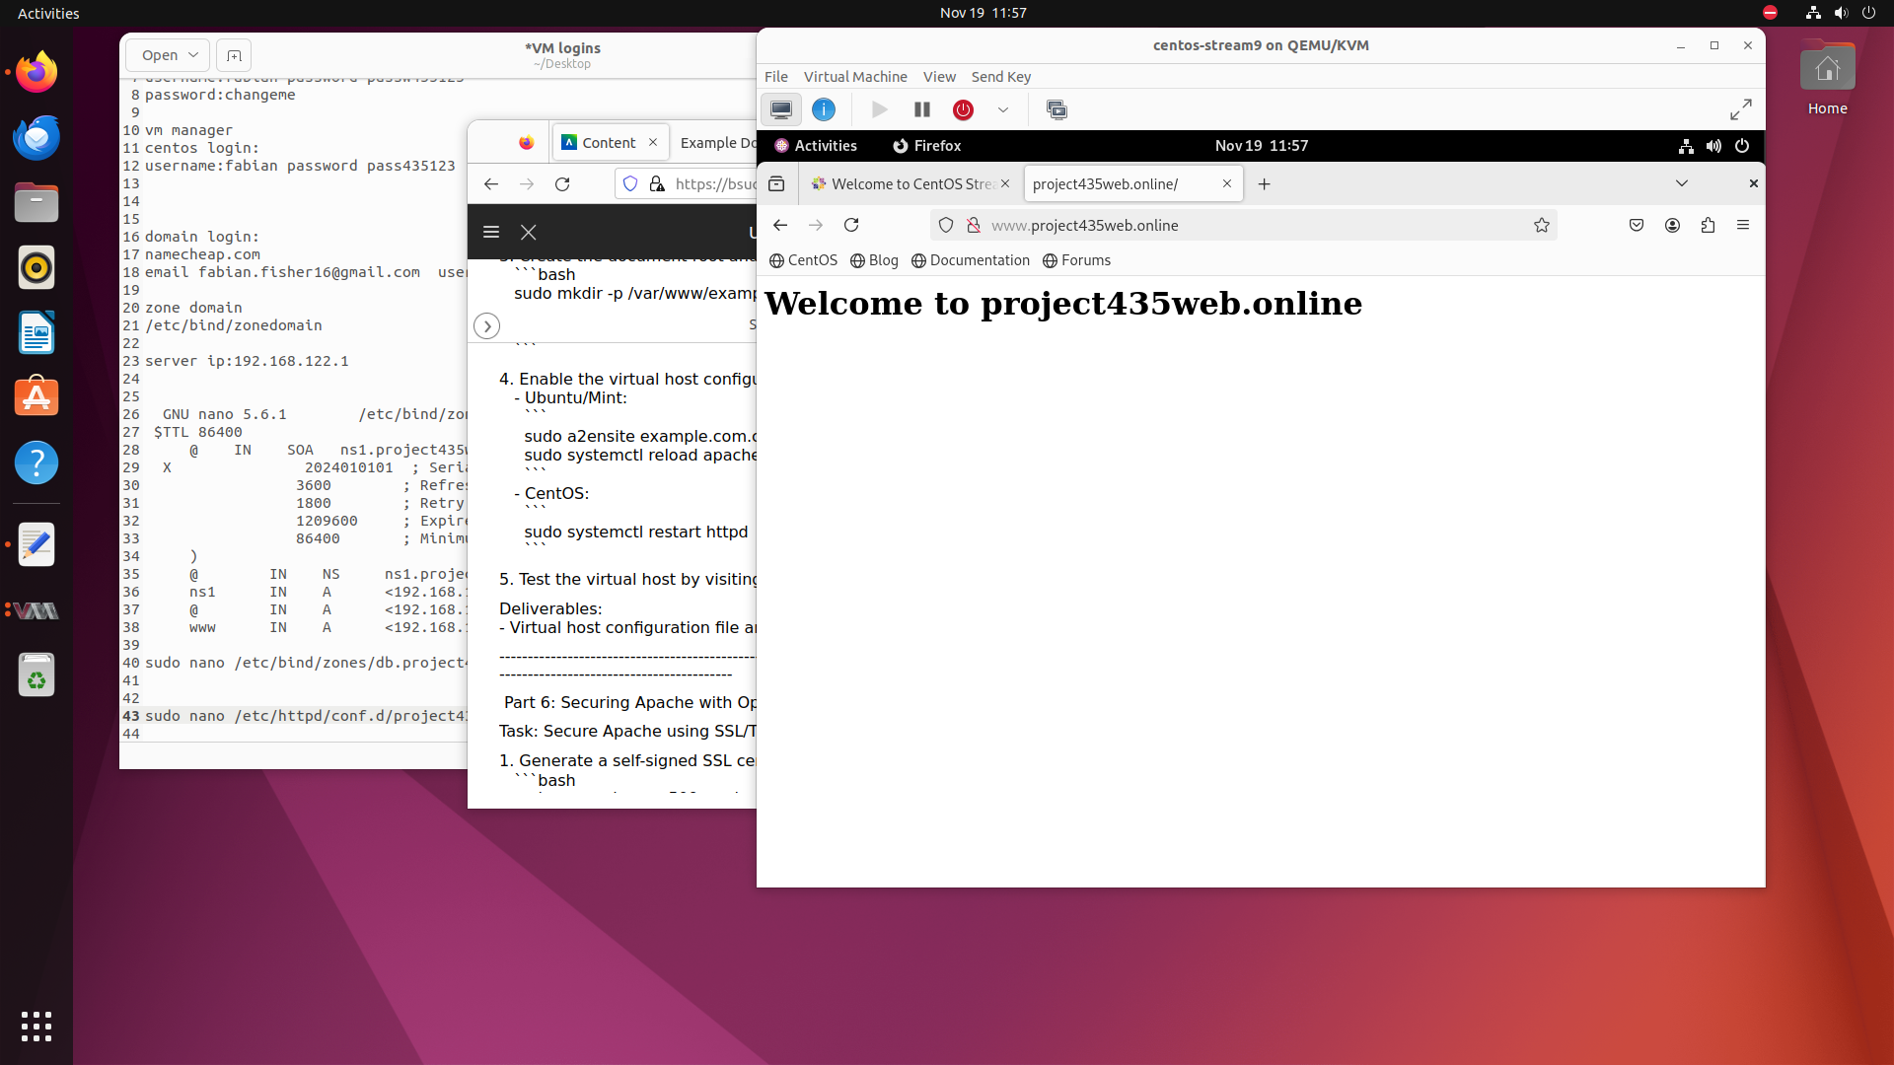

*Figure 11*

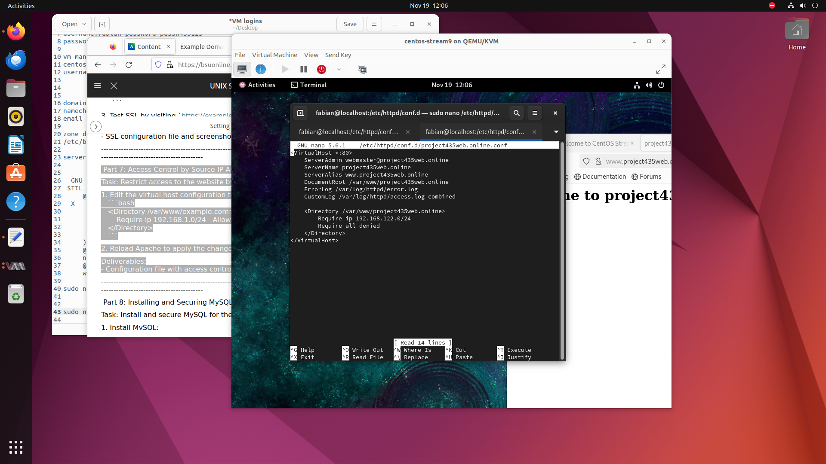

*Figure 12*

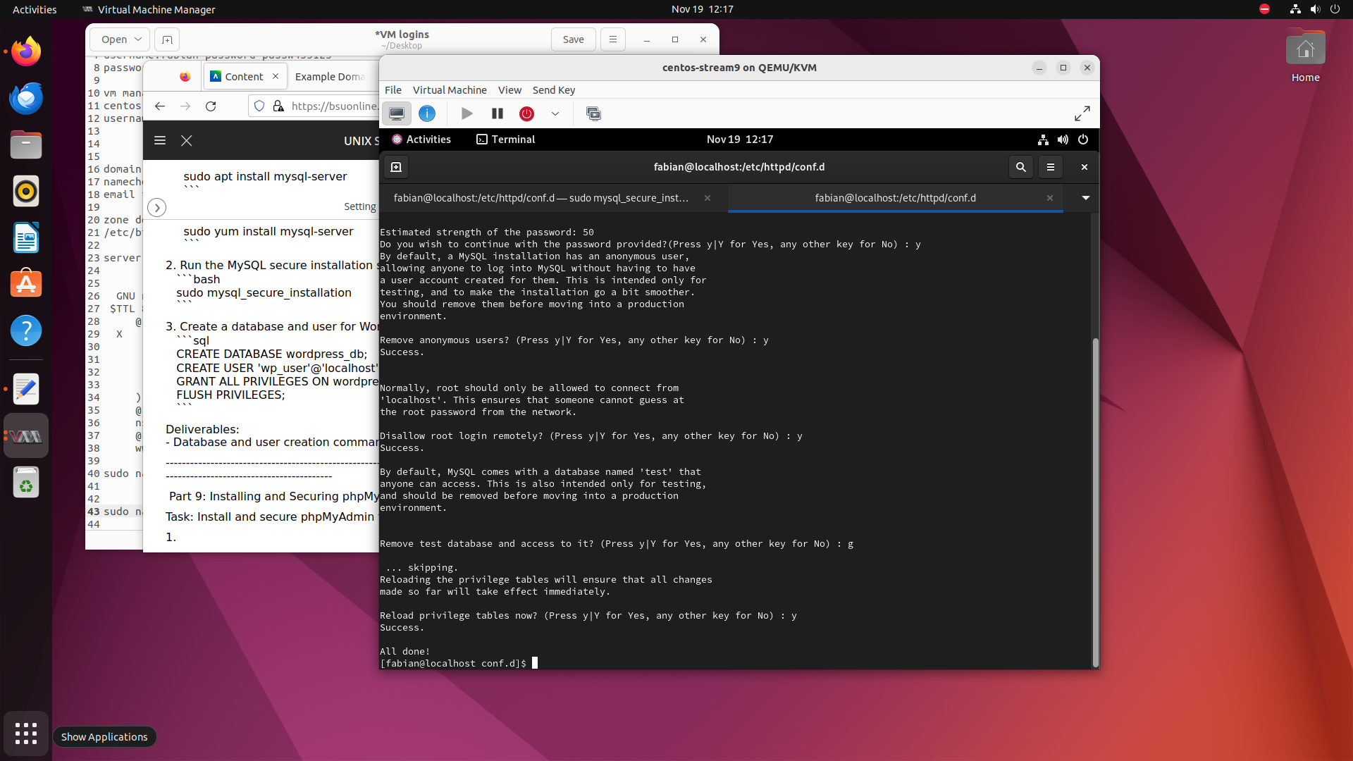

*Figure 13*

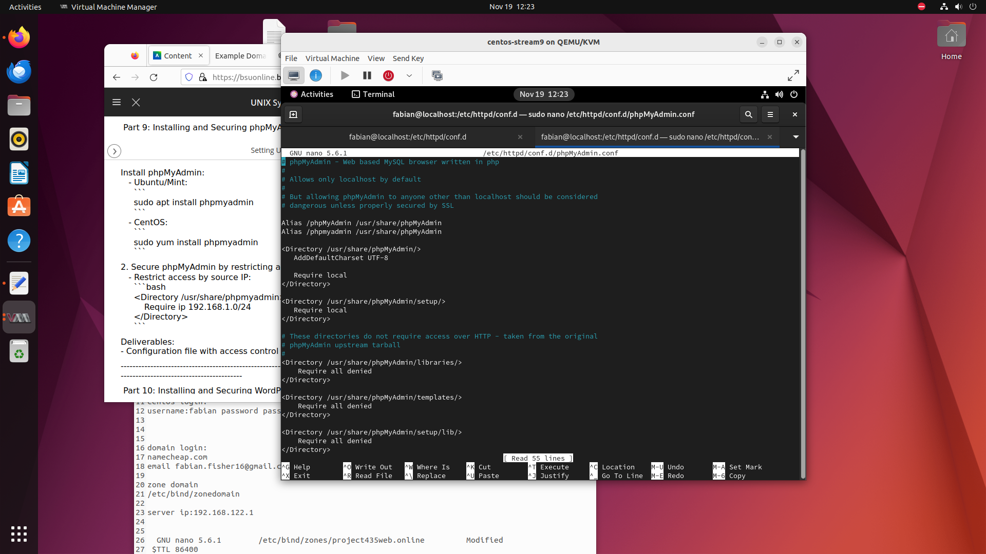

*Figure 14*

*Tasks:*

* *Setting up Virtual Hosting*
* *Virtual Host Configuration*
* *Root and Test web pages*
* *Securing Apache with OpenSSL and Digital Certificates*
* *Access Control by SOurce IP Address*
* *Installing and Securing MySQL Server*
* *Installing and Securing phpMyadmin*
* *Installing and Securing WordPress*

# Results

## What Is the Current Status?

Currently, web and DNS servers are evolving to meet increasing demands for security, speed, and reliability while facing challenges such as cyberattacks.

## Web Servers

Nginx leads the market with 39% usage, followed by Apache at 25% and Cloudflare Server at 22.6%. Emerging players like LiteSpeed (6%) are growing due to better performance optimization for dynamic sites. (As of Nov 14)

## 

## DNS Servers

Cloudflare is the fastest DNS resolver globally, prioritizing privacy by minimizing logging. Google Public DNS and OpenDNS also remain key players, focusing on reliability and widespread compatibility.

## Current Issues

Both web and DNS servers face sophisticated attacks like DDoS and ransomware. Advanced protection measures, such as Anycast networks and encrypted DNS protocols, are becoming critical.

## How Are We Using It?

We are using web and DNS servers as part of the process of building and securing a website. This begins with registering a domain name, which provides an easily accessible address for users to reach the site. We then set up a Linux-based system to run the web server, configuring it to store and deliver website content over the internet. A DNS server is configured to translate the domain name into an IP address, allowing users to access the website through their browsers. To ensure the security of the server, measures are put in place to prevent unauthorized access, such as configuring the server to be non-writable by any IP address.

### 

## Benefits to Society

Web and DNS servers are essential to the functioning of the modern internet, benefiting society by enabling seamless access to information, services, and communication. Web servers deliver websites and applications quickly and reliably, supporting everything from online shopping to educational resources. DNS servers ensure smooth navigation by translating domain names into IP addresses, making it easier for users to find websites. Additionally, DNS services enhance privacy by encrypting data and minimizing logs. Together, these technologies drive economic growth, support digital innovation, and facilitate social connections. However, ongoing challenges like cyber threats and service outages require constant improvement to ensure they continue to have a positive impact on society.

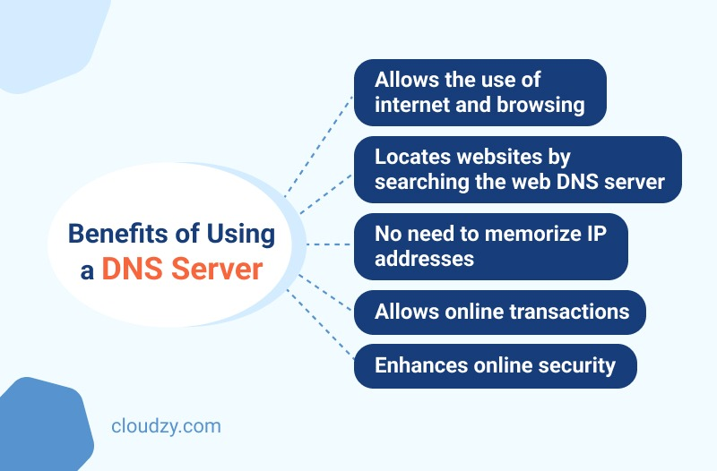

*Figure 15 Benefit to society*



*Figure 16 DNS server Created during project*

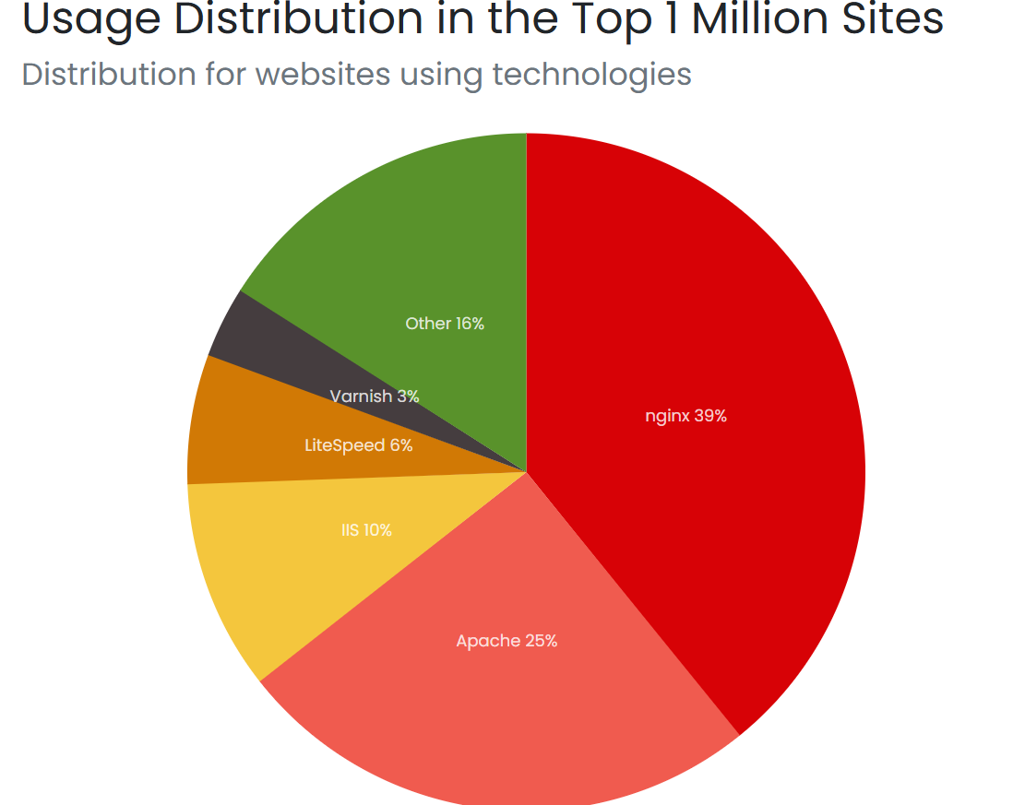

*Figure 17 web server usage as of nov 14*

# Future Work

While developing technology continues to emerge it is possible to redesign the setup of the linux system that was used to design the server. Instead of pointing the DNS Server to the web domain we thought of linking the two together to reduce any latency. Future developments could establish a secure server not applicable to threats such as DDOS attack or overloading.

# Summary and Conclusions

The report serves as an overview on the configuration process to set up a Web and DNS Server. Focusing on registering the domain and ensuring the website is accessible. Outlining the context of world wide web and historic contents of the DNS technology. The report also highlights the setup process using commands that were used. The setup process entails installing the web server software on a Linux Host device, using Ubuntu and CentOS. The next step was configuring the DNS server to communicate and translate domain names into the corresponding IP addresses. Throughout the project points were identified as key tasks needed to complete and establish checkpoints. The reports demonstrate the outline of the web domain and DNS server, taking into account the NGinx, Apache and Cloudflare, and other challenges that pose a threat to the system.

Although the configuration of the Web domain and DNS Server is a key part to establish a functional system. Integration and implementation of the developing system not only enhances user access to domain names but also highlights the critical need for strong security measures to address the continuously evolving cyber threats. By analyzing the historical trends and contemporary developments in server technology, along with their societal effects, organizations can more effectively navigate the intricate landscape of web hosting and DNS management.

Continuous progress and proactive security practices are vital to maintaining the efficient and functioning of these systems, thereby positively impacting the digital environment and society at large. This project has provided us with important insights into the architecture and functionalities of web and DNS servers, establishing a solid foundation for successful implementation and future research in this domain. We have gained a comprehension understanding of how web servers and DNS systems work together to deliver content reliably and efficiently, additionally we have analyzed common performance optimization techniques which are critical for handling high traffic and ensuring low latency in real world applications. This project has highlighted the challenges and problem solving thinking ability you will need when working in a group environment.

# References

*CERN Accelerating Science*. (n.d.). A short history of the web. Retrieved November, 2024, from https://home.cern/science/computing/birth-web/short-history-web

Petrova, B. (2023, May 30). *DNS history. When and why was DNS created?* ClouDNS. Retrieved November 26, 2024, from https://www.cloudns.net/blog/dns-history-creation-first/

Sinah, S. (2024, October 19). *Web Servers Concept*. Silex Softwares. Retrieved November 26, 2024, from https://www.silexsoftwares.com/how-do-web-servers-work

*Virtualization*. (2024, November 14). SUSE Documentation. Retrieved November 26, 2024, from <https://documentation.suse.com/smart/virtualization-cloud/html/virtualization/index.html>

Web Server technologies Web Usage Distribution. (n.d.). <https://trends.builtwith.com/web-server>

Global DNS Network Benefits. (2023, February 16). *DNS Made Easy Blog*. https://dnsmadeeasy.com/post/global-dns-network-benefits